Chapter 15, Problem 19.

Calculate the Laplace transform of the infinite train of unit impulses in Fig. 15.31.

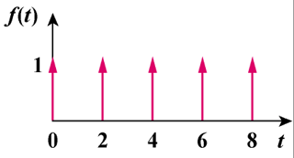

Figure 15.31
For Prob. 15.19.

